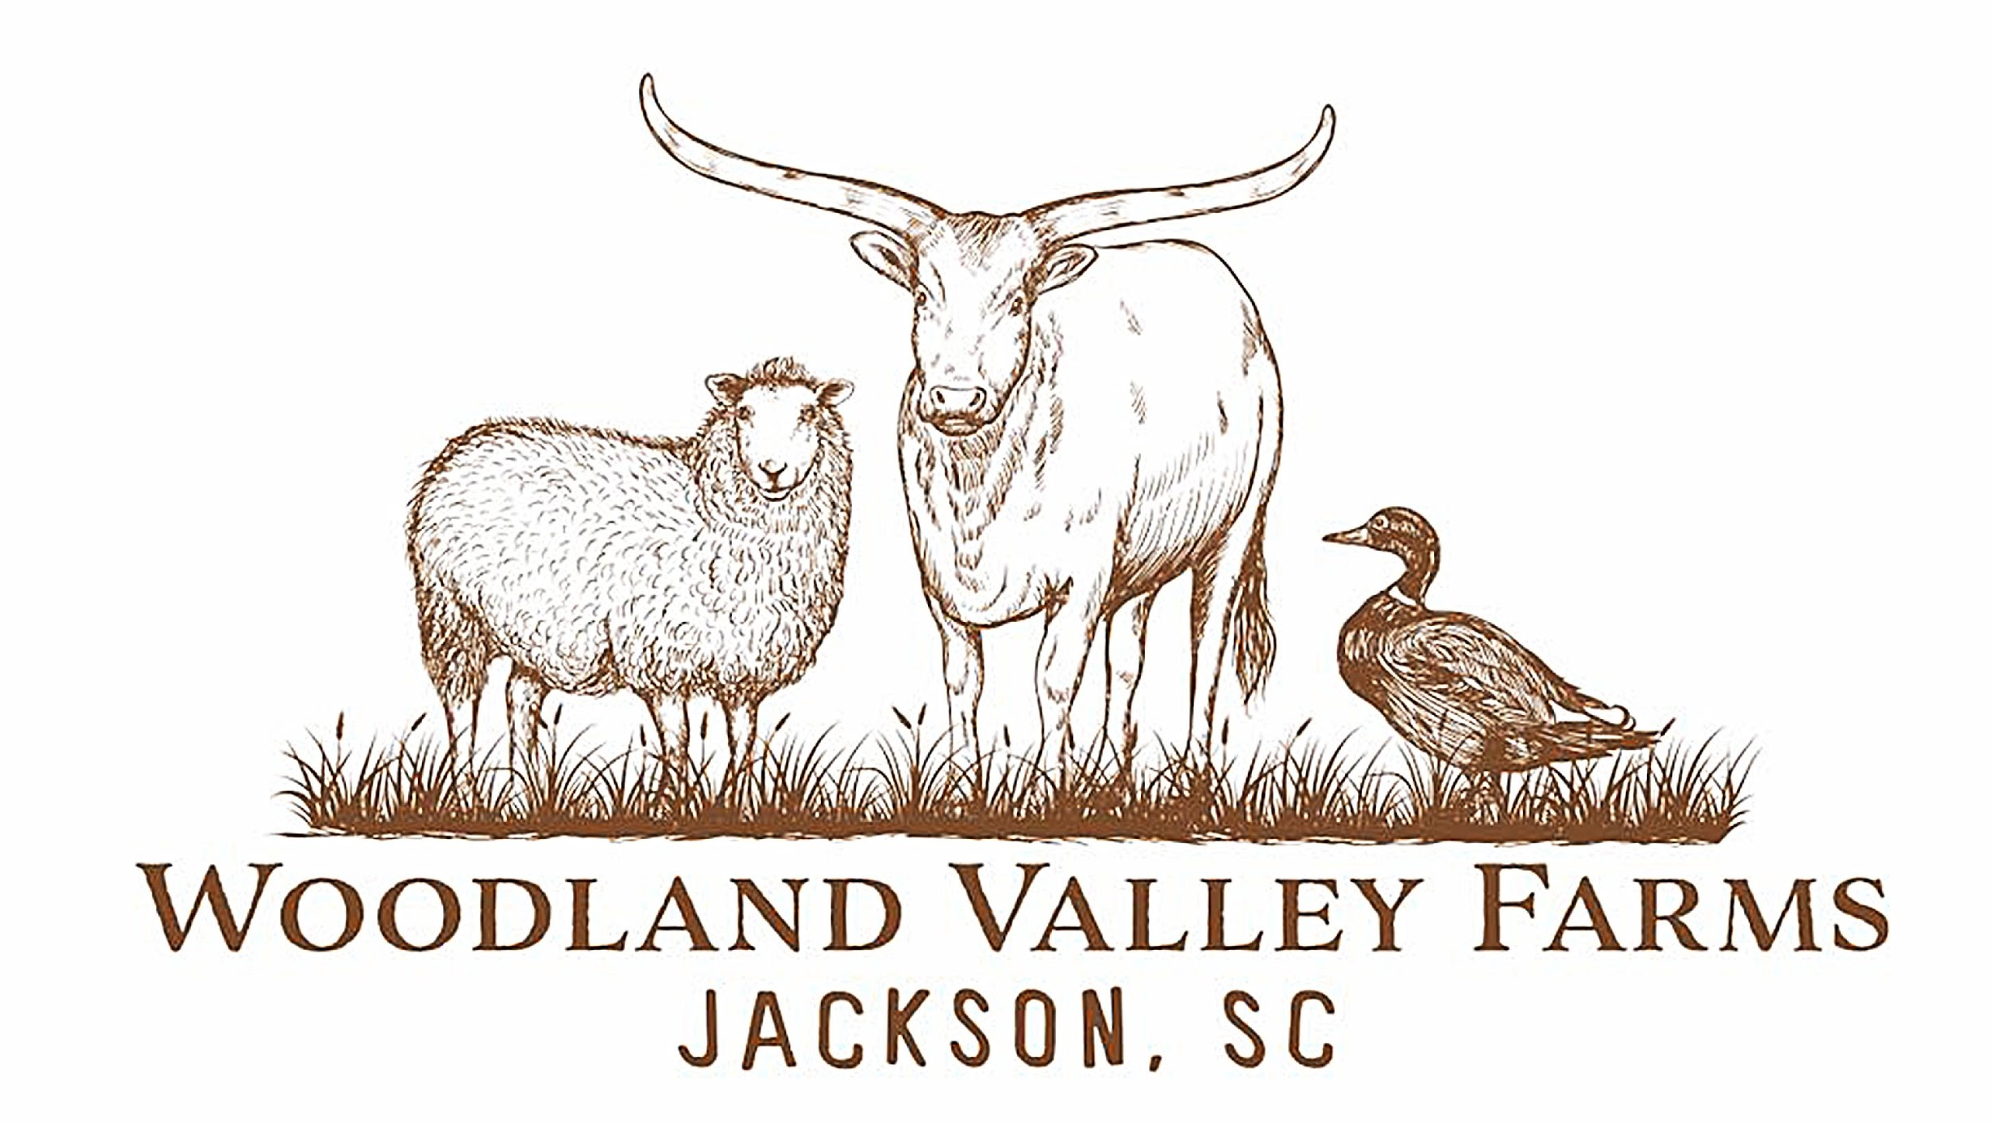

Chase Renninger
301-466-1276
woodlandvalleysc@gmail.com

All products are antibiotic, chemical, and wormer free. Standards and practices exceed organic regulations. Grass and forest fed animals. All natural.
Pastured Poultry, Heritage Breed Grass Based Chicken
- Whole Chickens $5.85/lb.
- Chicken Sausage $11.00/lb
- Ground Chicken $10.00/lb
- Chicken Breast $12/lb.
- Leg & Thigh $8.50/lb.
- Chicken Wings $7.50/lb.
- Chicken Livers $8.50/lb.
- Chicken Soup Bones $3.50/lb
- Chicken Feet $4.00/lb

Non-GMO Forest Fed Pork
- Thick Cut Pork Chops $15.50 / lb. 2 per pack
- Pork Tenderloin Roast $22.50/lb.
- Pork Shoulder $9.50lb
- Whole Ham $9.5/lb. / Half Ham $10/lb.
- Ham Steak $12.50/lb.
- Ground Pork $9.50/lb.
- Linked Sausage $10.50/lb.
- Non­Cased Ground Sausage is $10.50/lb.
- Pork Ribs $10/ lb.
- Pork Riblets $11/lb
- Pork Belly $13.00/lb
- Bacon $14.50 /lb. Nitrate and preservative free
- Heritage Pork Fat and Leaf Lard
  - $5/lb. Uncured
  - $8/lb. Leaf Lard
- Smoked Pork Jowl $15.50/lb.
- Ham Hocks $11.50/lb.
- Pork Liver $7/lb.
- Stock Bones $5/lb.
- Bulk Pricing Includes Vacuum Sealed packaging and full butcher. Sausage and Bacon will be an additional fee of approximately $1.00/lb. We require a deposit of $350 to hold your pig for you until butcher weight has been reached.
  - Whole Hogs $7.50/lb. Half Hog $8.00/lb. Quarter Hog $9.00/lb.

100% Grass-Fed Lamb
- Pre-ordered Whole Lambs $13/lb.
- Loin Chops $24/lb.
- Rack of Ribs/Rib Chops $24/lb.
- Boneless Shoulder Roast $18/lb.
- Bone­-In Leg of Lamb $16/lb. whole and half legs.
- Lamb Shanks $13/lb.
- Lamb Leg Steaks $18/lb.
- Ground Lamb $14/lb.
- Lamb Kabob $16/lb.
- Lamb Soup Bones $6.50/lb.
- Lamb Organs
  - Lamb liver ($10/lb.), heart ($5 ea.), kidneys ($4/set)

Grass-fed Beef
- Ground Beef $9.00/lb
- Steak Kabob Meat $12.50/lb
- Chuck Roast/Pot Roast $11.00/lb
- Beef Brisket $11.50/lb
- Sirloin Steak $14.50/lb
- Filet Mignon $25.00/lb
- Rib-Eye $19.00/lb
- Ny Strip $18.00/lb
- Short Ribs $9.00/lb
- Beef Liver $8.50/lb
- Cross Cut Shanks for Osso Bucco $9.00/lb
- Beef Bones for Stock $6.50/lb

- Eggs
- Non-GMO Pasture Raised Duck Eggs $8.00/ dozen
- Non- GMO Pasture Raised Chicken Eggs $6.50/dozen

